

AUG-DEC
2024
Unit 1: HTML, CSS AND CLIENT-SIDE SCRIPTING

Name: | SRN: | Section:
Name: | Date: | Unit 1 Assignment  Exercise

PROBLEM STATEMENT1 (for ODD number SRNs):

Create an Olympics Games 2024 survey form template using HTML tags headings, paragraphs, anchor tags, tables, images, forms and lists.

This HTML template should include:
- Heading “Olympics Games 2024 Paris”.
- An overview of the olympics highlights in a table with the table heading “Olympics Games 2024 Highlights” with the following:

(i) Background color to the table and page.
(ii) Row span and column span wherever needed.
(iii) Border line.
(iv) Use internal CSS only for styling the webpage.
(v) Basic JavaScript function to handle the feedback form submission.
The web page should display
- Form consisting of multiple fields which should include
  - Textboxes
  - Labels
  - Radio buttons
  - Dropdowns

- Use internal CSS only for styling the webpage.

AUG-DEC
2024
Unit 1: HTML, CSS AND CLIENT-SIDE SCRIPTING

- Add an Olympics logo at the right top corner to the page using the image
tag.

- A survey form to collect the user's name, email, phone number, gender, favorite event and preferred date for attending.

- Validate the form fields using input properties
  - All the fields in the form are required.
  - Email should be in proper format
  - Mobile number field should consist of exactly 10 digits
  - Reset button to be there to reset all the fields..
  - ‘Date of request’ date should be dd-mm-yyyy format
  - Checkbox should be checked before submitting the form.

- Use the reset button to clear all fields.Make use of a function for on submit button click, using JavaScript to display “Thank you, successfully submitted <user’s name>!” as an alert message.

- Use the reset button to clear all fields.

AUG-DEC
2024
Unit 1: HTML, CSS AND CLIENT-SIDE SCRIPTING

OBJECTIVE
The objective of this exercise is to test the student on HTML. It evaluates the student’s knowledge on the basic HTML tags for displaying images, lists, tables, forms and links, CSS Styles and JavaScript Basics.

PREREQUISITE
In order to complete this exercise, the student needs to understand the fundamentals of HTML and CSS. The student must be familiar with the basic HTML tags for creating links, lists etc., CSS and JavaScript.

PROGRAM
SCREENSHOT OF YOUR OUTPUT

AUG-DEC
2024
Unit 1: HTML, CSS AND CLIENT-SIDE SCRIPTING

SCREENSHOT OF OUTPUT (reference)
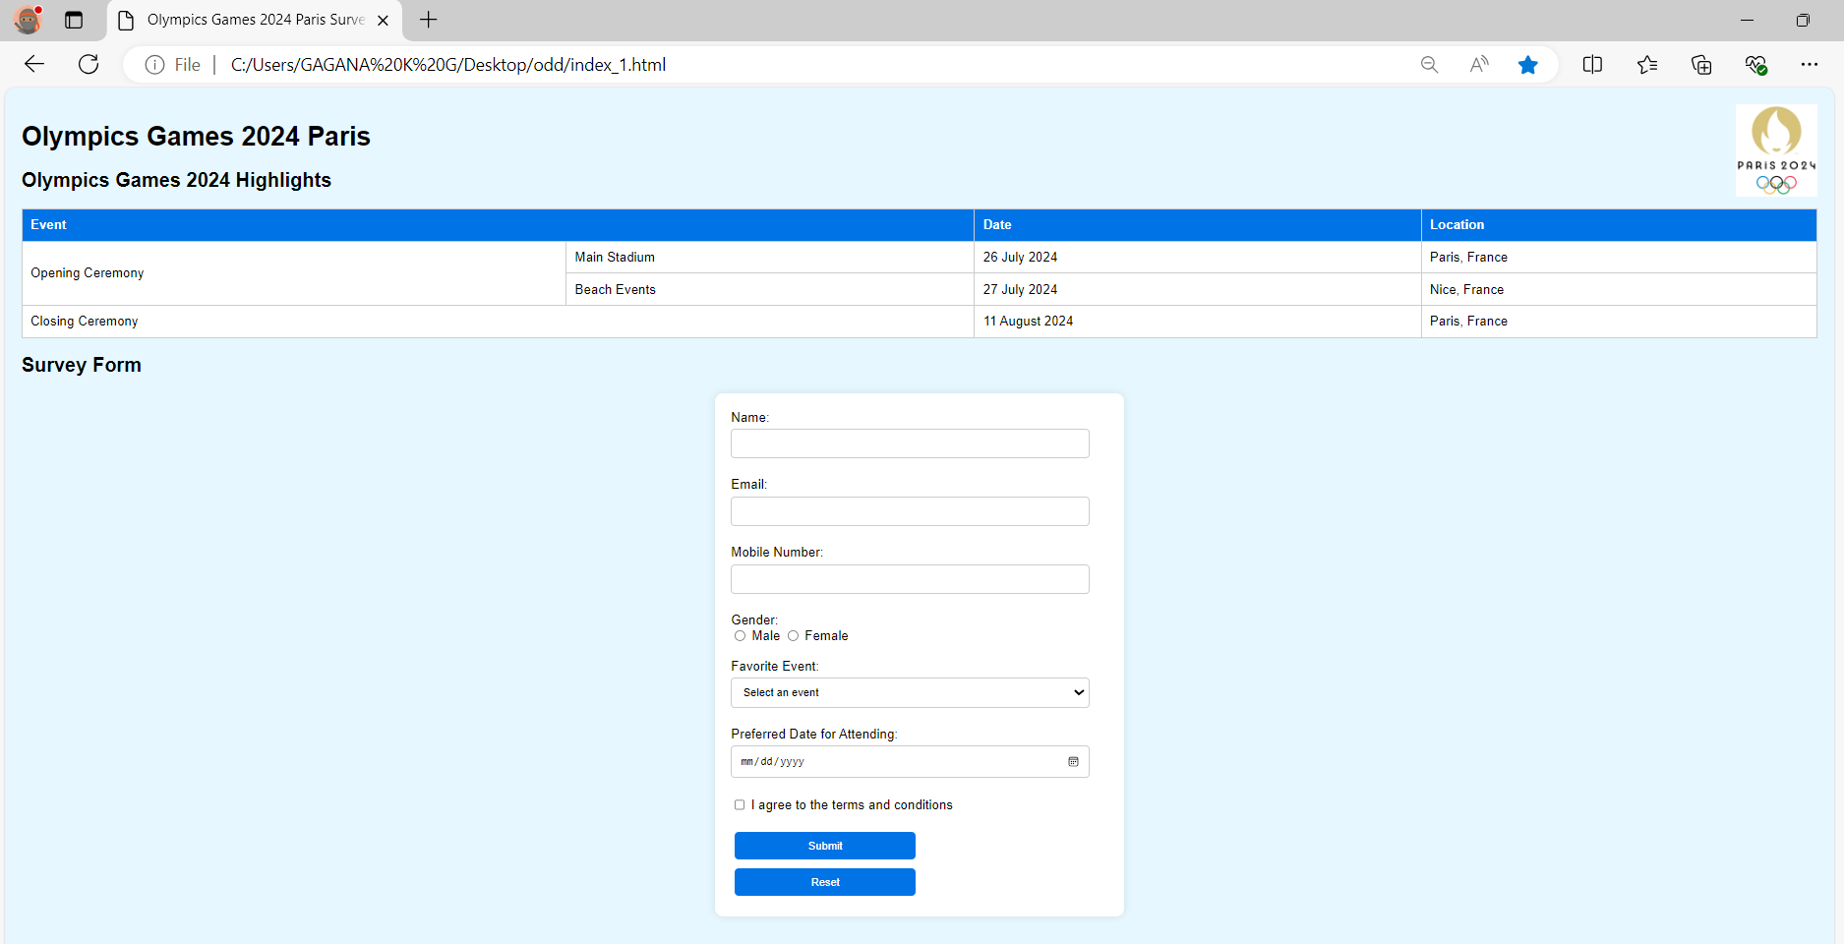

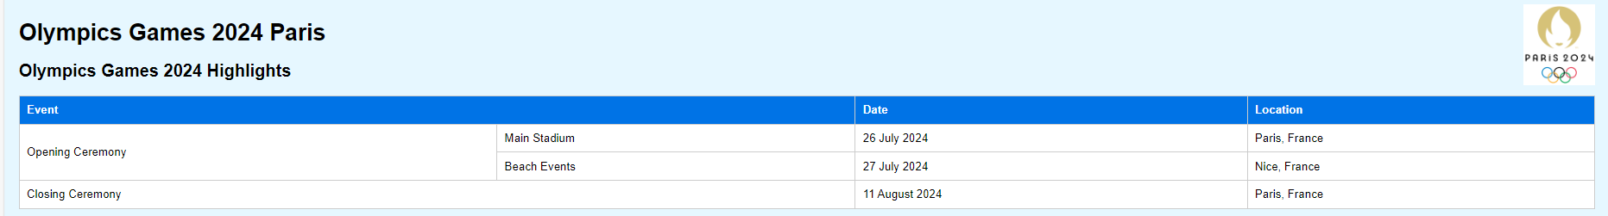

AUG-DEC
2024
Unit 1: HTML, CSS AND CLIENT-SIDE SCRIPTING

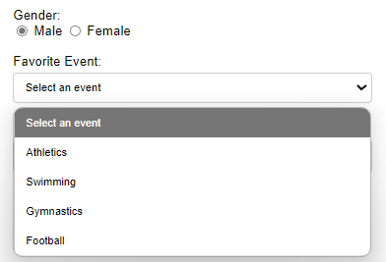

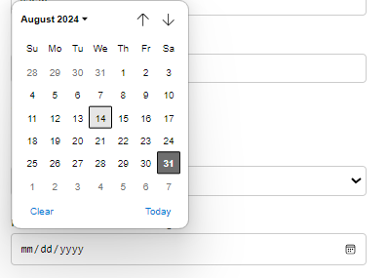

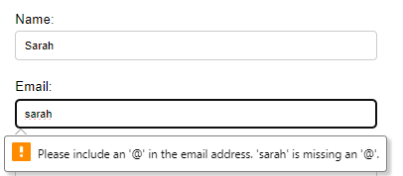

AUG-DEC
2024
Unit 1: HTML, CSS AND CLIENT-SIDE SCRIPTING

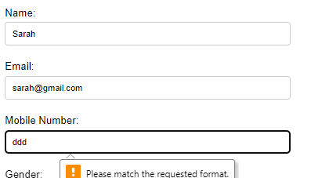

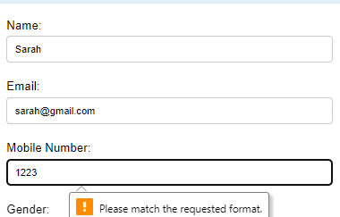

AUG-DEC
2024
Unit 1: HTML, CSS AND CLIENT-SIDE SCRIPTING





